http://www.drugdeliverytech.com/cgi-bin/articles.cgi?idArticle=152

Articles: PLGA-PEG Block Copolymers for Drug Formulations
By: Kang Moo Huh, PhD; Yong Woo Cho, PhD; and Kinam Park, PhD
ABSTRACT
Over the past few decades, biodegradable polyesters, such as poly(lactic acid) (PLA), poly(glycolic acid) (PGA), and poly(lactic-co-glycolic acid) (PLGA), have been extensively studied for a wide variety of pharmaceutical and biomedical applications. The biodegradable polyester family has been regarded as one of the few synthetic biodegradable polymers with controllable biodegradability, excellent biocompatibility, and high safety. The need for a variety of drug formulations for different drugs and delivery pathways resulted in development of various types of block copolymers (eg, diblock, triblock, multiblock, and star-shaped block) consisting of the biodegradable polyesters and poly(ethylene glycol) (PEG). Extensive studies throughout the world have produced encouraging results demonstrating many desirable, unique properties of PLGA-PEG block copolymers. Despite successes in preclinical applications and ever-increasing uses in diverse research activities, PLGA-PEG block copolymers are currently not available commercially. Recognizing that demands for PLGA-PEG block copolymers in pharmaceutical and biomedical applications will continue to grow, Akina, Inc., (www.akinainc.com/polycelle) has started production of PLGA-PEG block copolymers for those who want to use the block copolymers but are not willing to synthesize themselves. This article describes synthesis of PLGA-PEG block copolymers and their applications as drug delivery vehicles, such as micro/nano-particles, micelles, hydrogels, and injectable delivery systems.

INTRODUCTION
Recently, biodegradable polymers, especially poly(lactic acid) (PLA), poly(glycolic acid) (PGA), and poly(lactic-co-glycolic acid) (PLGA), have been used significantly in pharmaceutical and biomedical applications. Poly(lactic acid), poly(glycolic acid), and poly(lactic-co-glycolic acid) have also been called polylactide, polyglycolide, and poly(lactide-co-glycolide), respectively, according to the nomenclature system based on the source of the polymer. Although these names were used in many references in the past, a recent trend is to follow the nomenclature system of the International Union of Pure and Applied Chemistry (IUPAC) that is based on the repeating unit structure. PLA, PGA, and PLGA can be degraded into non-toxic substances and removed from the human body. Accordingly, they have taken center stages in a variety of research efforts.
The biodegradable polyesters are all strongly hydrophobic, and this has caused some limitations in practical drug formulations. To add hydrophilic and other physico-chemical properties, poly(ethylene glycol) (PEG) has been incorporated into the biodegradable polyesters. PEG is a non-toxic, water-soluble polymer with proven biocompatibility. Block copolymers consisting of a hydrophobic polyester segment and a hydrophilic PEG segment have attracted large attention due to their biodegradability, biocompatibility, and tailor-made properties. A wide variety of drug formulations, such as micro/nano-particles,¹ micelles,² hydrogels,³ and injectable drug delivery systems⁴ have been developed using PLGA-PEG block copolymers. They have been extensively investigated for use in a wide range of applications, including implantable materials, drug delivery systems, and tissue engineering scaffolds. They are very useful materials for pharmaceutical and biomedical applications, and thus they have significant commercial potential. Demands for the block copolymers will continue to grow, and they are expected to build a great market as their precursors, such as PLA, PGA, and PLGA, did. This review includes synthetic methods of PLGA-PEG block copolymers and their applications in controlled drug delivery. In addition, availability and significance of commercial production of the block copolymers are briefly described.
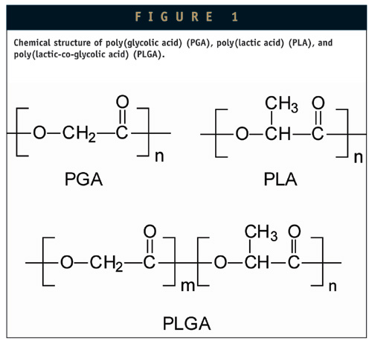
PLA, PGA & PLGA AS BIOMATERIALS
Biodegradable polymers have been extensively used in controlled drug delivery. They have the advantage of not requiring surgical removal after they serve their intended purposes. PGA, PLA, and especially their copolymers PLGA are the most commonly used family of biodegradable polymers. PGA was used as a biodegradable suture material in the 1970s, and it has led the largest volume production in the biomedical polymer markets, when its production was combined with those of PLA and PLGA.⁵ Since then, they have found a broad range of pharmaceutical and biomedical applications based on their unique properties, including versatile degradation kinetics, non-toxicity, and biocompatibility.⁶ The general properties and typical applications of PGA, PLA, and PLGA are summarized in Table 1.
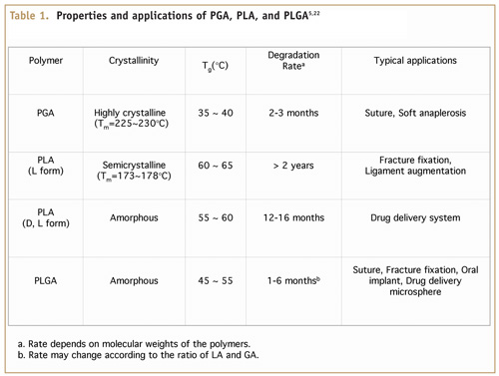
PGA is a highly crystalline polymer and the most hydrophilic among them. It has a very high melting point (224°C to 226°C), and the degradation rate of PGA is much higher than that of PLA. Random PLGA copolymers with different ratios of lactide (LA) and glycolide (GA) exhibit different degradation rates, and thus can be tailor-made for specific applications requiring specific degradation kinetics ranging from weeks to months. They are generally more amorphous than their homo-polymers and become most susceptible to hydrolysis when the two monomer contents are the same.
SYNTHESIS OF PLGA-PEG BLOCK COPOLYMERS
One useful strategy for modifying the physicochemical and biological properties of hydrophobic and biodegradable PLA, PGA, and PLGA has been to incorporate hydrophilic PEG segments. It is known that low molecular weight PEGs are easily excreted in humans. Many synthetic methods were developed to prepare various kinds of block copolymers with different block structures and compositions.
The biodegradation rate and hydrophilicity of block copolymers can be modulated by adjusting the ratio of its hydrophilic and hydrophobic constituents. Usually, PLGA-PEG block copolymers have shown quite different properties when compared to each constituting polymer. For this reason, PLGA-PEG block copolymers became a new family of biomaterials with their own unique properties, such as microphase separation, crystallinity, water-solubility, and biodegradability. Various kinds of block copolymers have been developed to date and can be classified according to their block structure as AB diblock,⁷ ABA,^{1,8} or BAB^{4,9} triblock, multi-block,^{10,11} branched block,¹² star-shaped block,¹³ and graft block¹⁴ copolymers, in which A is a hydrophobic block made up of biodegradable polyesters and B is a hydrophilic PEG block, as shown in Figure 2.
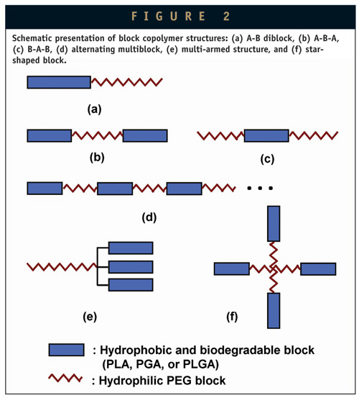
Homo- and copolymers of LA and GA are usually synthesized by ring-opening polymerization of cyclic monomers. The block copolymers can be synthesized using various kinds of different catalysts, but also in the absence of catalysts. One of the most widely used catalysts is stannous octoate. Figure 3 shows a typical example for synthesis of PLGA-PEG block copolymers using stannous octoate. The terminal hydroxyl groups of PEG have been used as the initiating groups to synthesize block copolymers. Therefore, ring opening polymerization of lactide and glycolide initiated by dihydroxy PEG or monomethoxy PEG can lead to A-B-A or A-B type block copolymers, respectively.⁹ B-A-B type block copolymers can be obtained by coupling the diblock copolymers using hexamethylene diisocyanate. Alternating multiblock copolymers of PLA and PEG can be synthesized by polycondensation reaction between dihydroxy PEG and dicarboxylated PLA.¹⁰ Dicarboxylated oligomeric PLAs were synthesized as macro-monomers by the condensation reaction of lactic acid in the presence of succinic acid. Kissel et al. reported star-shaped block copolymers from multi-arm PEG and lactide or lactide/glycolide.¹⁵ Biodegradable star-shaped PLA-PEG and PLGA-PEG block copolymers can be synthesized by ring opening polymerization in the presence of 4- or 8-branched PEG using aluminum triethylene as a catalyst.
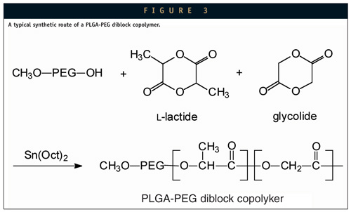
PROPERTIES OF PLGA-PEG BLOCK COPOLYMERS
One typical characteristic of PLGA degradation is autocatalysis by which heterogeneous bulk degradation is observed with a decrease in pH. Carboxylic end groups of degraded products, oligomeric PLGA, can accelerate the degradation and decrease the local pH in PLGA formulations. This locally acidified environment is known to be a main reason for protein inactivation and often requires incorporation of antacids, such as Mg(OH)₂, into the polymers for protein stabilization by neutralization.¹⁶ In addition, other limitations, such as hydrophobicity, brittleness, and toxicity, have been reported with PLGA formulations. Block copolymers containing hydrophilic PEG segments have attracted considerable attention as an alternative approach for overcoming such undesirable effects and improving the properties in applications of PLGA as drug delivery vehicles. Through various synthetic processes, diverse block copolymers with a wide range of molecular weights, chemical structure, and hydrophilic/hydrophobic block ratios have been prepared and used in controlled drug delivery.
The chemical composition and molecular weight of block copolymers determines their water-solubility and degradation kinetics. Polymers with low molecular weight or composed of shorter hydrophobic blocks are soluble in water, whereas high molecular weight polymers and polymers with longer hydrophobic blocks are not soluble but swell in water. In general, the degradation time will be shorter for low molecular weight polymers, more hydrophilic polymers, more amorphous polymers, and copolymers with higher content of glycolide. Therefore, at identical conditions, low molecular weight copolymers of lactide and glycolide will degrade relatively rapidly, whereas the high molecular weight homopolymers, PLA, and PGA will degrade much more slowly.
PLGA-PEG BLOCK COPOLYMERS IN DRUG FORMULATIONS
Various types of drug formulations, such as nano/micro-particles, hydrogels, micelles, and injectable delivery systems have been developed using PLGA-PEG block copolymers to deliver hydrophobic drugs as well as hydrophilic peptide and protein drugs. The ability of the polymers to entrap drugs and subsequently release them at a controlled rate has been used to develop various drug formulations.
Nano/Microparticles
ABA triblock copolymers are more hydrophilic than PLA or PLGA itself, and are considered more suitable for development of delivery systems for hydrophilic macromolecular drugs, such as peptides, proteins, and oligo/polynucleotides. Micro- and nano-particles prepared from AB diblock and ABA triblock copolymers are extensively investigated for protein drug delivery.^{1,17-19} Block copolymer nano/microparticles are generally prepared by water/oil/water (W/O/W) double emulsion method, as shown in Figure 4. The W1 phase, an aqueous phase containing protein drugs, is dispersed into the oil phase consisting of polymer dissolved in organic solvent (eg, dichloromethane) using a high-speed homogenizer. The primary water-in-oil (W/O) emulsion is then dispersed to an aqueous solution containing a polymeric surfactant, eg, poly(vinyl alcohol) (PVA), and further homogenized to produce a W/O/W emulsion. After stirring for several hours, the nano/microparticles are collected by filtration. They show quite different release patterns when compared with PLGA. Kissel at al. reported that ABA triblock copolymers showed a continuous and molecular mass-dependent release while the release from PLGA was biphasic and almost independent of the molecular mass of entrapped substances.⁸
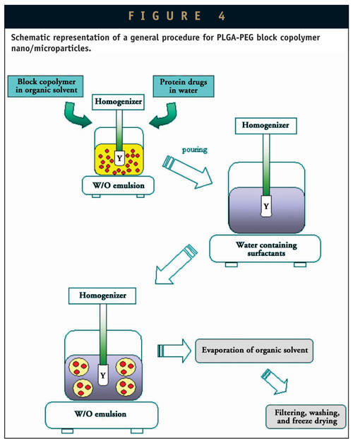
Polymeric Micelles
Amphiphilic PLGA-PEG block copolymers form micelles composed of a hydrophobic PLGA core and hydrophilic PEG shell in water, as shown in Figure 5. Hydrophobic blocks are segregated from the aqueous exterior to form an inner core surrounded by a palisade of hydrophilic segments. Block copolymer micelles are water-soluble, biocompatible nanocontainers in the size of 10~100 nm with proven efficacy of delivering hydrophobic drugs. These micelle-forming block copolymers can provide high concentration of hydrophobic drugs with increased drug stability in an aqueous milieu above the solubility limit of the drug. The ability of polymeric micelles to target certain cells (eg, cancer cells) can also lower the required dosage.²⁰ The size and morphology of block copolymer micelles can be easily changed by adjusting the chemical composition, total molecular weight, and ratio of the block lengths. Various hydrophobic drugs, including paclitaxel,² have been incorporated into the hydrophobic inner core of micelles.
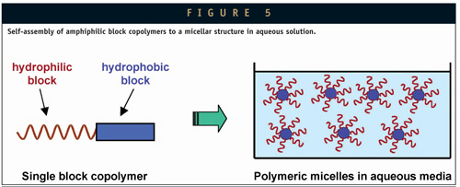
Hydrogels
When the block copolymers have high molecular weights and high PLGA contents, they become water-insoluble but can swell in water. Block copolymers consisting of hydrophilic and hydrophobic blocks are able to form physical crosslinking in an aqueous environment through hydrophobic interaction, crystalline microdomains or chain entanglement.³ Physical associations of hydrophobic domains maintain swollen soft domains together and keep the polymer network stable in water. Although physical associations are reversible and weaker than chemical crosslinking, they allow solvent casting and thermal processing, and the resulting polymer gels often possess elastic or viscoelastic properties. These biodegradable, physical hydrogels may offer an alternative material of choice in designing drug delivery systems as well as other biomedical applications.¹¹
Injectable Drug Delivery Systems
Aqueous solutions of low molecular weight B-A-B type triblock copolymers are well known to have thermo-reversible sol-gel transitions, forming in situ hydrogels without harmful organic solvents or any chemical reactions.^{4,9,21} Figure 6 schematically represents the thermo-reversible sol-gel transition of the triblock copolymers. The system can be loaded with drugs in aqueous phase at low temperature (below critical gelation temperature) where it forms a sol. Just following subcutaneous injection, the elevated temperature to 37°C (above critical gelation temperature) makes the injected sol to a gel that can act as a sustained-release matrix for the loaded drugs. Thermo-reversible hydrogels have recently attracted large attention due to the simplicity of drug formulation by solution mixing, biocompatibility with biological systems, and convenient administration. Pharmaceutical and biomedical applications of the block copolymers include solubilization of low molecular weight hydrophobic drugs, controlled release of labile biomacromolecules (eg, proteins and genes), cell immobilization, and tissue engineering.
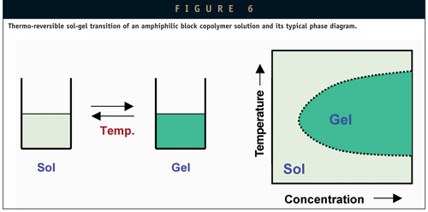
LACK OF COMMERCIAL SOURCES FOR PLGA-PEG BLOCK COPOLYMERS
Biodegradable polymers have been playing a key role in various pharmaceutical and biomedical research and product development. Materials that can degrade and disappear from the body are desirable for a number of applications, including orthopedics, tissue engineering, and controlled drug delivery systems. For this reason, a number of commercial sources supply PLA, PGA, and PLGA throughout the world. However, there are no commercial sources supplying block copolymers consisting of hydrophobic blocks of PLA, PGA, or PLGA and hydrophilic PEG blocks. These block copolymers have unique properties that homopolymers cannot provide, and are ideal for formulating controlled drug delivery systems and for making scaffolds for tissue engineering. Yet their commercial introduction has not been made to date. Demands for these block copolymers are expected to grow as the pharmaceutical and biomedical fields continue to grow.
COMMERCIAL PRODUCTION OF PLGA-PEG COPOLYMERS
During the past few decades, significant advances have been made in polymeric drug delivery technology. Drug delivery in the future will need more sophisticated and diverse formulations for existing drugs as well as new drugs, such as protein and peptide drugs. Biodegradable polymers have an important role in the development of controlled-release formulations. PLGA-PEG block copolymers have a number of unique and useful properties that are ideal for controlled drug delivery. The properties of sol-gel transition at well-defined temperatures and biodegradability make block copolymers an ideal delivery vehicle for various drugs, including protein drugs. Numerous new protein drugs are expected in the near future as a result of an increased understanding of genomics and proteomics. Thus, demands for the PLGA-PEG block copolymers are expected to grow exponentially for both research and product development in the coming years. To meet the current needs and prepare for the future demands, Akina, Inc., started producing biodegradable PLGA-PEG block copolymers for those who wish to use them in their research and development of drug delivery systems (www.akinainc.com/polycelle).
Synthetic methods for the block copolymers are well established, and Akina produces block copolymers consisting of glycolide, lactide, and PEG. These three main building blocks can be assembled into a wide variety of different combinations to synthesize block copolymers with diverse, but tailor-made, properties. Properties, such as degradation rate, hydrophilicity, cystallinity, and solubility, can be easily custom-made for specific applications.
______________

REFERENCES
- Morlock M, Kissel T, Li YX, Koll H, Winter G. Erythropoietin loaded microspheres prepared from biodegradable LPLG–PEO–LPLG triblock copolymers: protein stabilization and in-vitro release properties. J Control Rel. 1998;56:105-115.
- Liggins RT, Burt HM. Polyether-polyester diblock copolymers for the preparation of paclitaxel loaded polymeric miecelle formations. Adv Drug Delivery Rev. 2002;54:191-202.
- Hoffman AS. Hydrogels for biomedical applications. Adv Drug Delivery Rev. 2002;43:1-12.
- Jeong B, Bae YH, Lee DS, Kim SW. Biodegradable block copolymers as injectable drug-delivery systems. Nature. 1997;388:860-862.
- Ikada Y, Tsuji H. Biodegradable polyesters for medical and ecological applications. Macromol Rapid Commun. 2000;21:117-132.
- Chaubal M. Polylactides/glycolides-excipients for injectable drug delivery and beyond. Drug Delivery Technology. 2002;2:34-36.
- Beletsi A, Leontiadis L, Klepetsanis P, Ithakissios DS, Avgoustakis K. Effect of preparative variables on the properties of poly(dl-lactide-co-glycolide)-methoxypoly(ethyleneglycol) copolymers related to their application in controlled drug delivery. Int J Pharm. 1999;182:187-197.
- Kissel T, Li Y, Unger F. ABA-triblock copolymers from biodegradable polyester A-blocks and hydrophilic poly(ethylene oxide) B-blocks as a candidate for in situ forming hydrogel delivery systems for proteins. Adv Drug Delivery Rev. 2002;54:99-134.
- Jeong B, Bae YH, Kim SW. Drug release from biodegrdable injectable thermosensitive hydrogel of PEG-PLGA-PEG triblock copolymers. J. Control Rel. 2000;63:155-163.
- Huh KM, Bae YH. Synthesis and characterization of poly(ethylene glycol)/poly(-lactic acid) alternating multiblock copolymers. Polymer. 1999;40:6147-6155.
- Bae YH, Huh KM, Kim Y, Park KH. Biodegradable amphiphilic multiblock copolymers and their implications for biomedical applications. J Control Rel. 2000;64:3-13.
- Hrkach JS, Peracchia MT, Domb A, Lotan N, Robert L. Nanotechnology for biomaterials engineering: structural characterization of amphiphilic polymeric nanoparticles by 1H NMR spectroscopy. Biomaterials. 1997;18:27-30.
- Breitenbach A, Li YX, Kissel T. Branched biodegradable polyesters for parenteral drug delivery systems. J Control Rel. 2000;64:167-178.
- Jeong B, Kibbey MR, Birnbaum JC, Won YY, Gutowska A. Thermogelling biodegradable polymers with hydrophilic backbones: PEG-g-PLGA. Macromolecules. 2000;33:8317-8322.
- Li Y, Kissel T. Synthesis, characteristics and in vitro degradation of star-block copolymers consisting of L-lactide, glycolide, and branched multi-arm poly(ethylene oxide). Polymer. 1998;39:4421-4427.
- Zhu G, Mallery SR, Schwendeman SP. Stabilization of proteins encapsulated in injectable poly(lactide-co-glycolide). Nature Biotechnol. 2000;18:52-56.
- Li YP, Pei YY, Zhang XY, Gu ZH, Zhou ZH, Yuan WF, Zhou JJ, Zhu JH, Gao XJ. PEGylated PLGA nanoparticles as protein carriers: synthesis, preparation and biodistribution in rats. J Control Rel. 2001;71 203-211.
- Gref R, Lück M, Quellec P, Marchand M, Dellacherie E, Harnisch S, Blunk T, Müller RH. Stealth corona-core nanoparticles surface modified by polyethylene glycol (PEG): influences of the corona (PEG chain length and surface density) and of the core composition on phagocytic uptake and plasma protein adsorption. Colloids and Surfaces B: Biointerfaces 2000;18:301-313.
- Choi Y, Kim SY, Kim SH, Lee KS, Kim C, Byun Y. Long-term delivery of all-trans-retinoic acid using biodegradable PLLA/PEG/PLLA blended microspheres. Int J Pharm. 2001;215:67-81.
- Savic R, Luo L, Eisenberg A, Maysinger D. Micellar nanocontainers distribute to defined cytoplasmic organelles. Science. 2003;300:615-618.
- Jeong B, Kim SW, Bae YH. Thermosensitive sol-gel reversible hydrogels. Adv Drug Delivery Rev. 2002;54:37-51.
- Middleton JC, Tipton AJ. Synthetic biodegradable polymers as medical devices. Medical Plastics & Biomaterials. 1998;5(2)30-39.

BIOGRAPHIES
Dr. Kang Moo Huh is a Principal Scientist at Akina, Inc., where he is engaged in research projects related to the development of biodegradable block copolymers and superporous hydrogels for drug delivery and tissue engineering applications. Dr. Huh earned his BS in Polymer Science and Engineering from Chungnam National University (South Korea), his MS in Materials Science and Engineering from Kwangju Institute of Science and Technology (South Korea), and his PhD in the School of Materials Science from Japan Advanced Institute of Science and Technology (Japan). He completed his Post-doctoral research at the Biomedical Center of Korea Institute of Science and Technology, where he participated in the development of polymeric gene carriers and injectable hydrogels. Research interests include design and synthesis of stimuli-sensitive polymers and hydrogels, polymeric micelles as delivery carriers for hydrophobic drugs, biodegradable amphiphilic block copolymers, and supramolecular-structured hydrogels using host-guest interactions for biomedical applications.
Dr. Yong Woo Cho is a Principal Scientist at Akina, Inc., where he is involved in research projects on the development of polymeric micellar carriers for poorly soluble drugs and RNA enzyme delivery systems. He has considerable experience in the areas of biopharmaceutical formulation development, anti-tumor drug delivery, gene delivery, and tissue engineering. Dr. Cho earned his BS, MS, and PhD in the Department of Fiber and Polymer Science from Seoul National University, Seoul, Korea. He worked for the Korea Institute of Science and Technology as a Post-doctoral research associate, where he performed research projects on development of anti-tumor drug delivery systems, regeneration of defected tissues and organs, and development of antibiotics-releasing urethral catheters. Dr. Cho’s recent research interests include polymeric self-assemblies, biomimetic materials, and functional delivery systems to induce endosomal escape of genomics-based pharmaceuticals.
Dr. Kinam Park is the Founder of Akina, Inc., specializing in drug delivery technologies. He is also Professor in the Departments of Pharmaceutics and Biomedical Engineering of Purdue University. Dr. Park earned his PhD in Pharmaceutics from the University of Wisconsin in 1983. Following his Post-doctoral training in the Department of Chemical Engineering at the same university, he joined the faculty of Purdue University. Since 1998, he has the joint appointment in the Department of Biomedical Engineering. His current work at Akina is focused on development of controlled-release protein delivery systems using PLGA-PEG block copolymers, diet control aids using biodegradable superporous hydrogels, layer-by-layer coating technology for drug-eluting stents, and novel technology for developing fast-melting tablets.

